**Overview of PyQt and PySide Python Libraries**

**1. Introduction to PyQt and PySide**

PyQt and PySide are both Python bindings for the **Qt framework**, which is a powerful C++ library used for developing cross-platform GUI applications.

* **PyQt** is developed by Riverbank Computing.
* **PySide** is developed by Qt Group (formerly Nokia and The Qt Company).

Both libraries provide similar functionalities, but there are licensing differences:

* **PyQt** uses GPL and a commercial license.
* **PySide** uses LGPL, making it more flexible for commercial applications.

**2. Key Features of PyQt & PySide**

* Provides support for standard Qt widgets (e.g., QPushButton, QLabel, QLineEdit, QTableWidget).
* Offers a **signal and slot** mechanism for event handling.
* Supports layouts like **QVBoxLayout**, **QHBoxLayout**, and **QGridLayout**.
* Allows **Qt Designer** integration for designing UI visually.
* Provides support for **QSS (Qt Style Sheets)** for theming applications.

**3. Differences Between PyQt and PySide**

| **Feature** | **PyQt6** | **PySide6** |
| --- | --- | --- |
| License | GPL / Commercial | LGPL |
| Maintained By | Riverbank Computing | Qt Group |
| API Stability | Slightly different method names | Closer to C++ Qt API |
| Qt Designer Support | Yes | Yes |

In most projects, they are interchangeable. If using LGPL is a requirement, **PySide** is the preferred choice.

**Project Structure for a PyQt/PySide Application**

For better maintainability, a PyQt or PySide project should have a structured directory. Below is a recommended project structure:

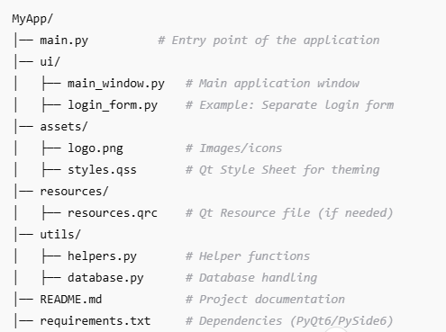

**Example Project Structure Explanation**

1. **main.py**: The entry script that initializes the application.
2. **ui/**: Contains all UI-related Python classes.
3. **assets/**: Stores images, icons, and style sheets.
4. **resources/**: Contains .qrc files for Qt resource management.
5. **utils/**: Includes helper functions, database connectivity, or configuration handlers.
6. **README.md**: Documentation explaining how to run and use the application.
7. **requirements.txt**: List of dependencies, e.g.,

PyQt6

PySide6

**Running a PyQt or PySide Project**

1. Install dependencies:

pip install PyQt6 # or pip install PySide6

1. Run the application:

python main.py